Software Requirements Specification
BE Projects 2011-12

ROBO SUMOS

Group: 5

UMESH NAIR

SREERAM KRISHNAN

VINOD SALUNKE

Table of Contents

1 Introduction 3
1.1 Definitions, Acronyms and Abbreviations 3
1.2 References 3
2 Overall Description 3
3 Details 6
3.1 Functionality 6
3.2 Supportability 7
3.3 Design Constraints 7
3.4 On-line User Documentation and Help System Requirements 7
3.5 Interfaces 8
3.5.1 User Interfaces 8
3.5.2 Hardware Interfaces 8
3.5.3 Software Interfaces 8
3.5.4 Communications Interfaces 8

- Quality Control … … …… …………………………………………….9

- Risk Management ……………………………………………………...9

Risks ………………………………………………………………………………………………9

Mitigation Plan …………………………………………………………………………………..9

- Introduction
Robo-sumo is a sport in which two robots attempt to push each other out of a circle (in a similar fashion to the sport of Sumo). The robots used in this competition are called sumo-bots.
This SRS describes the project requirements, functionality, design constraints along with risk management.

Definitions, Acronyms and Abbreviations

- Sumo Robot- Sumo robots are autonomous robots designed specifically for Sumo style competition.

- Zigbee- ZigBee is a low data rate, two-way wireless communications standard for industrial and domestic automation networks.

References

- www.wikipedia.org
- www.nex-robotics.com
- www.roboticsindia.com
- www.mathworks.in/matlabcentral/
- Projects from E-yantra

- Overall Description

Product Perspective

To develop code for processing images from a camera into instructions for controlling the motion of two robots as well as detecting the ring boundary, using which each robot would try to push the other out of the ring according to the rules of Sumo wrestling.

Product Functions

- Security/Patrolling: Patrolling a given area and pushing any intruder that tries to enter the area.

- Entertainment purpose

- Cleaning: Cleaning a predefined area off everything that’s present in the area.

User Characteristics

For security/patrolling purposes, the users are mainly the army and security personnel.

For Entertainment purposes, the users are spectators and robotics enthusiasts.

Constraints

- The arena has a limited area the diameter of the arena is about 75-80cm).
- The arena should be black in colour with a white boundary.
- The robot cannot be too heavy i.e. its weight cannot be more than 3kg.

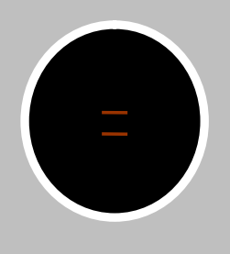

Assumptions and Dependencies

At present, we assume that the image that we receive from the camera would show contrasting colors for each robot so that they can be located accurately.

The robots depend on the overhead camera for locating the opponent’s position relative to its position, and also for detecting the ring boundary.

The robots depend on the Zigbee modules for transmitting and receiving data from its controller.

Requirements Subsets

- Image Processing using overhead camera.
- Wireless data transmission using Zigbee.
- Motion Control

- Details

Functionality

To be effective, a sumo-robo must be able to do the following:

- Stay in the circular ring
- Hunt for the opponent
- Target (Aim at) the opponent
- Attack (Push) the opponent
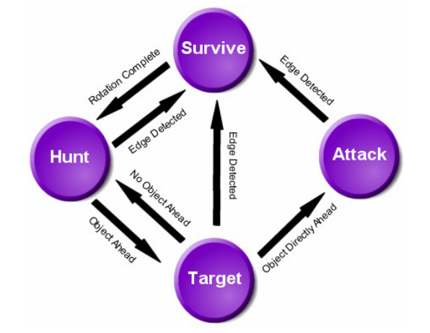
The camera mounted on top of the square arena will be continuously taking the image of whole arena. The location of the robot would be calculated with the help of coordinates.

The pixel position of the robot from the overhead camera would first be normalized, and then multiplied with the dimensions of the arena...thus giving the physical coordinates (location) of the robot.

Based on the location of the opposing robot each robo will align itself accordingly and move forward to push it outside the ring.

In order to avoid moving out of the ring, each robo would continuously sense the ring boundary using image processing from the overhead camera and if it detects the boundary, it would then try to change its direction and move towards the inside of the ring.

At the end robo with more power and better strategy will win the game. The Robo-sumo project will be implemented in C and MATLAB.

Supportability

The standard coding and naming conventions have been used.

Design constraints

- The Spark V robot used has a diameter of 15cm and a height of 7cm.
- The robot has a top speed of 15 to 20cm/sec.
- A single overhead camera is used for image processing for both the robots.

On-line User Documentation and Help System Requirements

The entire source code and logic developed during the course of this project would be well-documented and made available online for public reference.

Interfaces

User Interfaces

The user will be involved only in giving the start and end commands to 2 robots.

Hardware Interfaces

A Zigbee module is used for interfacing the controller with the robot.

Apart from that, the interfaces present on the Spark V robot would also be required.

Software Interfaces

Since the entire code would be developed by us, no extra software is required apart from µVision Keil for programming the robots and FlashMagic for burning the code onto the chip.

Communication Interfaces

Communication will take place between the 2 robots and their respective controllers (computer/laptop) using 4 ZigBEE modules.

- Quality Control

Test Data

The following tasks must be performed by each of the two sumo-bots and hence needs to be tested:-

- SURVIVE: Try and stay within the ring boundary.

- HUNT: Search and locate the opponent’s position.

- AIM/TARGET: Align itself to face the opponent straight ahead.

- ATTACK/PUSH: Move forward and push the opponent out of the ring.

- Risk Management

Risks

- Risk in Image Processing: The image received from the camera may not be accurate, i.e. they may contain a variety of intensity values, not necessary of a single color.

- Not Skilled in using MATLAB: The members of our group have beginner-level skills in MATLAB language.

Mitigation Plan

- For image processing, contrasting colors with different shapes can be used to reduce the risks involved.
- With proper guidance from your side, we are sure we can enhance our skills in MATLAB and use the same for the project.

